Pear Group Solutions Company

Sales history Business Concept.

# Overview

## Business Background

Assume that there is a company «Pear», which manufactures and sells equipment and software (CD players, DVD players, Cameras, Computers, Printers, Peripherals and Accessories, Software and etc.). The company «Pear» recently made ​​a breakthrough and was able to penetrate world markets. As a result, sales volume significantly increased, and the flow of information grew up to 1 million rows per day. Having spent some time in the world markets in the normal mode, the top management of the company came to the conclusion that for the further successful promotion of the brand «Pear» it is necessary to conduct a thorough analysis of the accumulated statistics on sales of the company's products in world markets. In this connection it became necessary to introduce a tool for analyzing incoming data to determine the positive / negative trends in sales worldwide according to the company’s purposes.

## Benefits

Proper evaluation of the company's offices in each region will promptly and fully respond to changes in economic conditions in world markets and as a result will enhance the effectiveness of the Company Information and its profit.

# Requirements

## Business Requirements

* colculate information about sales (amount, quantity) monthly for each country;
* colculate information about customers monthly;
* colculate information about products monthly;
* control information about total sales for each product category for each country raising alarm, if it’s less then 5% from region sales for this product;

## Technical Requirements

* High performance;
* High availability;
* 24/7 ability to receive and process information ;
* System must process all required source data from all mentioned below sources;
* System must perform information according to the company’s standards;
* All the information must be protected according to the company’s security Policy.
* Ability to process large amounts of information per day (1 million rows);

# Solution Sketch

## Source Tables structure

Customers

|  |  |
| --- | --- |
| NAME | DATA_TYPE |
| Cust_code | Number |
| Cust_first_name | Varchar2(20) |
| Cust_last_name | Varchar2(20) |
| Cust_gender | Char(2) |
| Cust_birth_year | number |
| Cust_marital_status | Char(6) |
| Cust_street_address | Varchar2(20) |
| Cust_city | Varchar2(20) |
| Cust_city_id | number |
| Cust_email | Varchar2(20) |
| Cust_credit_limit | Varchar2(20) |
| Cust_total | Varchar2(20) |
| Cust_income_level | Varchar2(20) |

Products

|  |  |
| --- | --- |
| NAME | DATA_TYPE |
| Prod_code | Number |
| Prod_name | Varchar2(20) |
| Prod_subcat | Varchar2(20) |
| Prod_cat | Varchar2(20) |
| Prod_price | Number (10,2) |
| Prod_desc | Varchar2(20) |
| Prod_pack_size | Number(10,2) |
| Prod_total | Varchar2(10) |
| Prod_valid | Varchar2(10) |
| Prod_weight | Number(10,2) |

Channels

|  |  |
| --- | --- |
| NAME | DATA_TYPE |
| Channel_name | Varchar2(20) |
| Channel_desc | Varchar2(20) |
| Channel_class | Varchar2(10) |
| Channel_total | Varchar2(10) |
| Channel_code | number |

Sales

|  |  |
| --- | --- |
| NAME | DATA_TYPE |
| Prod_code | number |
| Price | Number(10,2) |
| Quantity | Number(10,2) |
| Cust_code | number |
| Location_code | number |
| Channel_code | number |

## Summarize Data Plan

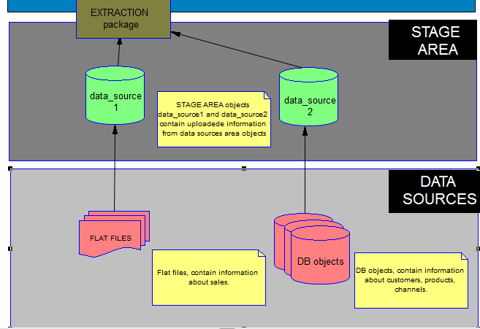

# DWH Solution Concept

## Logical Diagram

## Physical diagram

## Dimensions

### Dimension Types

### Dimension Hierarchies

## Facts

### Facts Aggregations

## Dataflow Diagram

## Partitioning rules

## Strategy of Parallel execution